Larger Numbers
We will get the smallest 7-digit number if we add one more to the greatest 6-digit number, which is called Ten Lakh.
Going forward if we add 1 to the greatest 7-digit number then we will get the smallest 8-digit number which is called One Crore.
Remark
1 hundred = 10 tens
1 thousand = 10 hundreds
= 100 tens
1 lakh = 100 thousands
= 1000 hundreds
1 crore = 100 lakhs
= 10,000 thousands
Pattern
9 + 1 = 10
99 + 1 = 100
999 + 1 = 1000
9,999 + 1 = 10,000
99,999 + 1 =1,00,000
9,99,999 + 1 = 10,00,000
99,99,999+1=1,00,00,000

Reading and Writing Large Numbers
We can identify the digits in ones place, tens place and hundreds place in a number by writing them under the tables O, T and H.

Crores |  | Lakhs |  | Thousands |  | Ones
Ten Crores (TC) | Crores (C) | Ten Lakhs (TL) | Lakhs (L) | Ten Thousands (TTh) | Thousands (Th) | Hendreds (H) | Tens (T) | Ones (O)
(10, 00, 00, 000) | (1,00,00,000) | (10, 00, 000) | (1,00,000) | (10,000) | (1000) | (100) | (10) | (1)
Example
Represent the number 5, 21, 05, 747
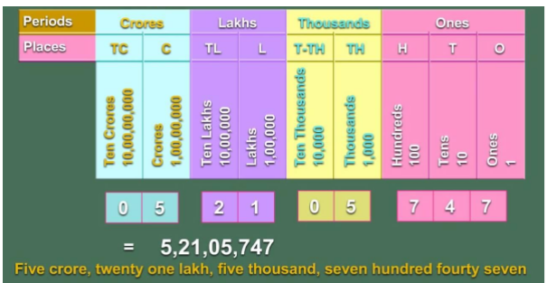

Use of Commas
We use commas in large numbers to ease reading and writing. In our Indian System of Numeration, we use ones, tens, hundreds, thousands and then lakhs and crores.
We use the first comma after hundreds place which is three digits from the right. The second comma comes after two digits i.e. five digits from the right. The third comma comes after another two digits which is seven digits from the right.
Example
5,44,12,940
Remark: We do not use commas while writing number names

